Machine learning and hurricane tracking

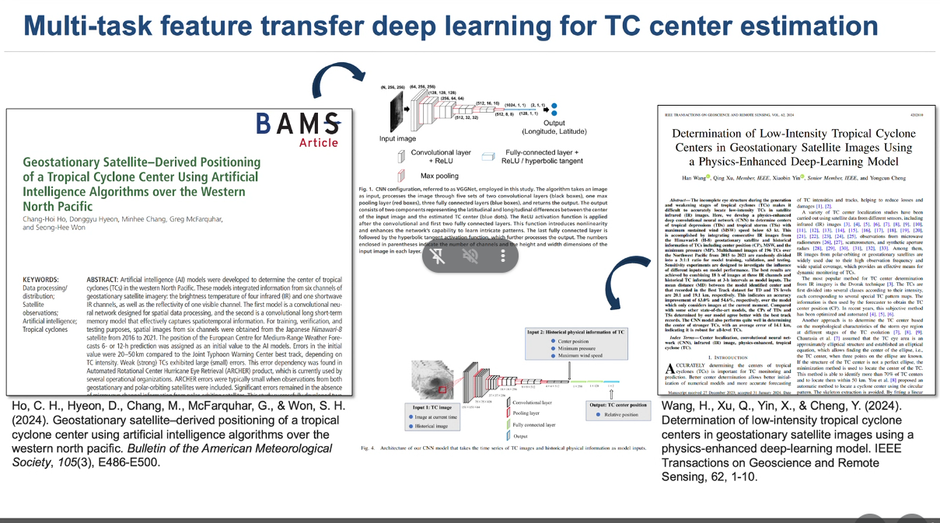

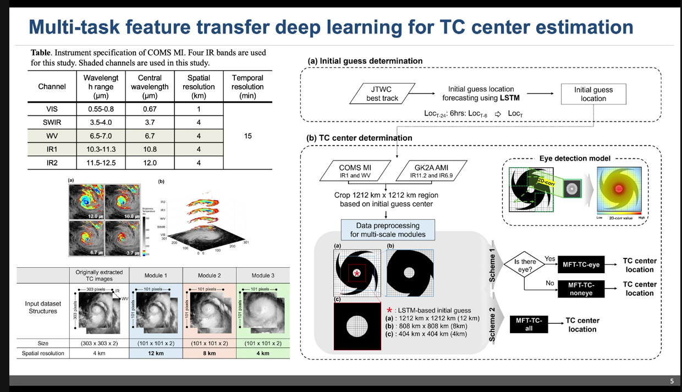

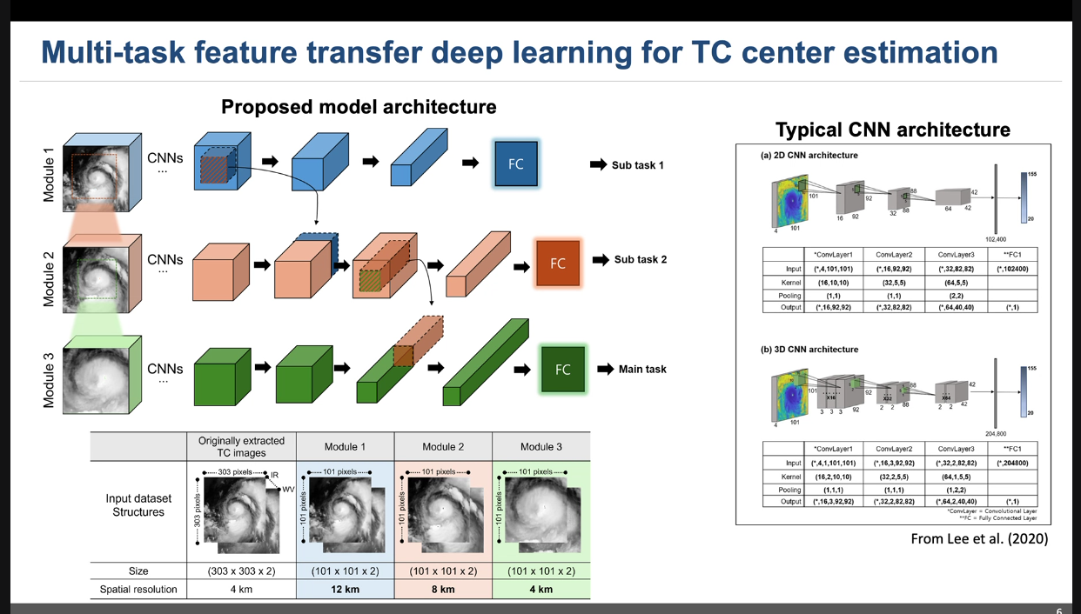

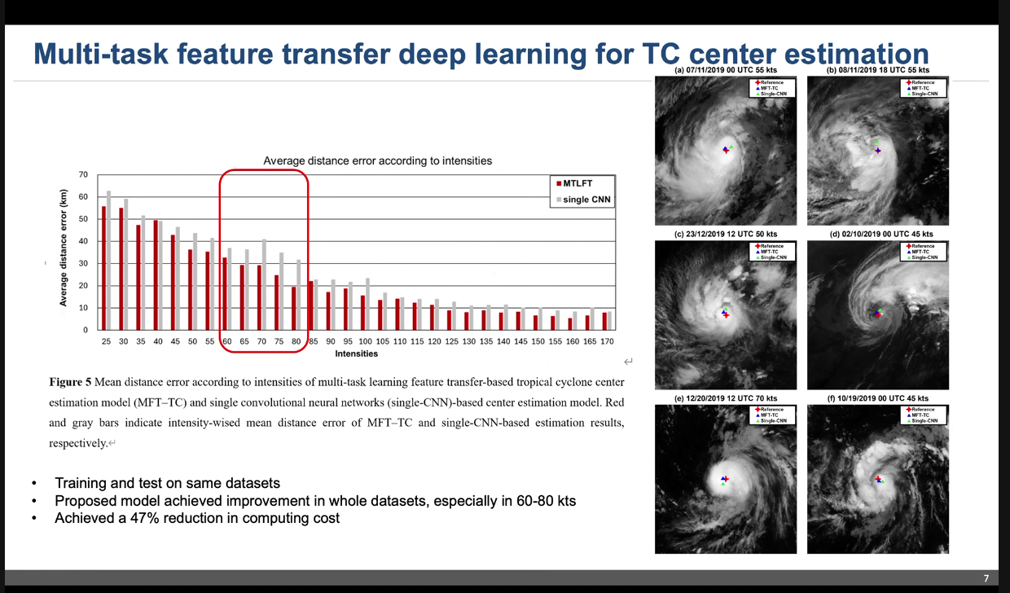

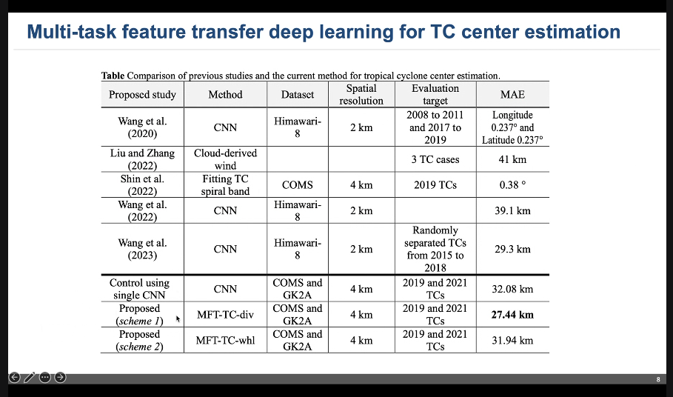

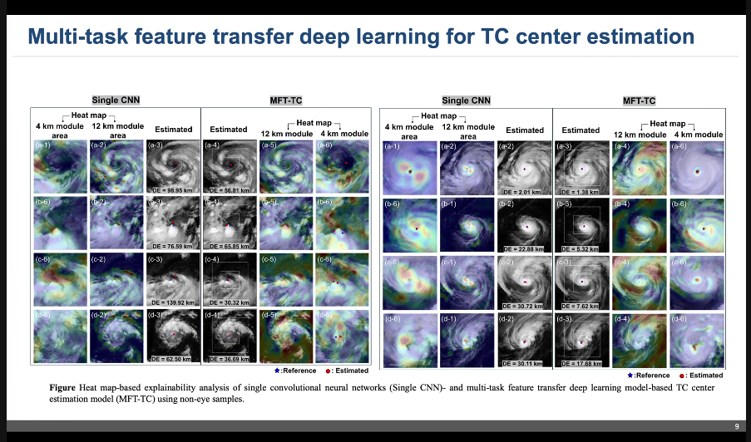

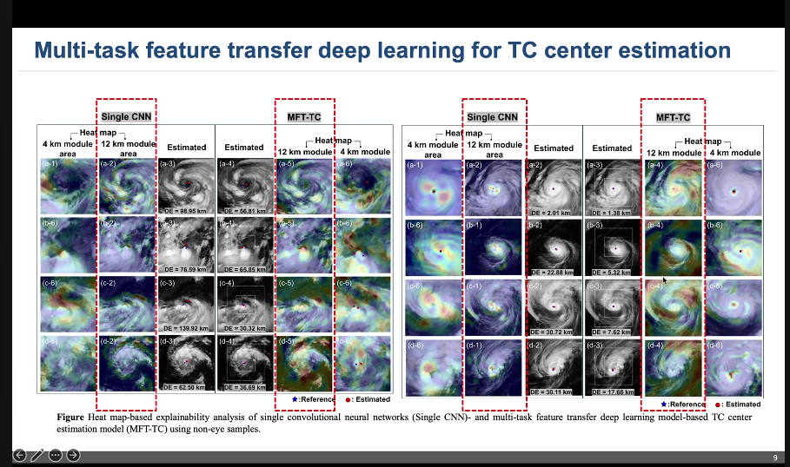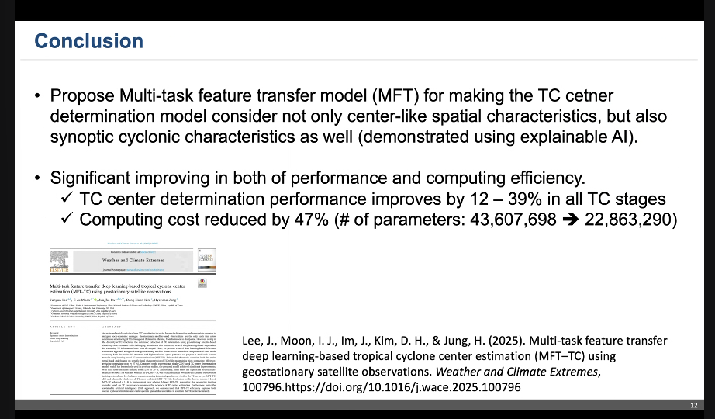

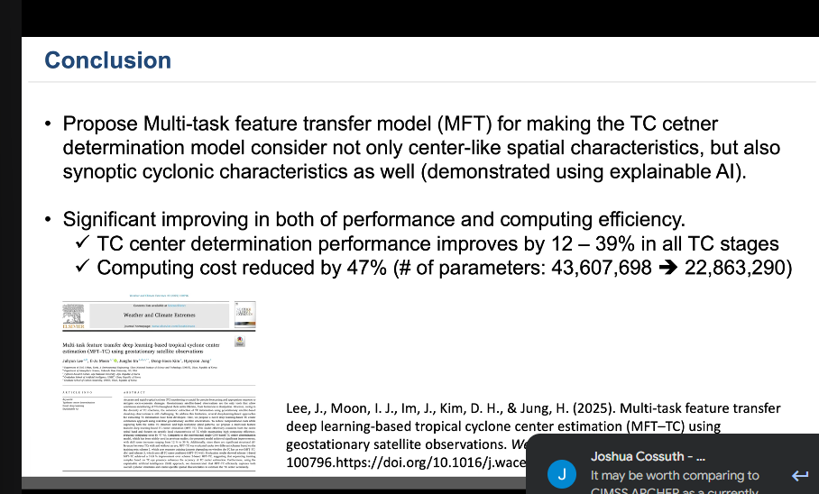

Considered each fragment of by themselves

Using only current real time observation

Heather

For each application

If nice stack, center at flight level fine

But more tilted, surface can be different account for that

Multiple aircraft can be different

Spline interpolations can get funky

Represented a vertically

Only used geostationary

Investigate

Using more than IR

Also combine water vapor channel

Vortex data message

Where flight level winds go to zero

Based on Flight level winds

Wind center may not be in geometric center